Copyright Filing Application Draft — UpTrend
1. Title of the Work
UpTrend – AI-Powered Stock Market Learning, Portfolio Simulation, and Paper Trading Platform
Abstract
UpTrend is a MERN-stack based web platform developed for stock market learning, portfolio simulation, and paper trading. The system integrates educational modules, AI-assisted guidance, market visualization, and virtual trading into a unified platform. Users can learn trading concepts, execute virtual buy/sell operations using simulated capital, monitor portfolio performance, and analyze market trends through interactive dashboards and charts.
Objective
The objective of UpTrend is to provide beginners with a risk-free environment for learning stock market concepts and practicing trading strategies using simulated trading tools and educational resources.
Core Modules
• User Authentication
• Dashboard Analytics
• Educational Academy
• Portfolio Management
• Paper Trading Engine
• Market Visualization
• AI Assistance
Operational Workflow
- User logs into the platform.
- Dashboard loads portfolio and learning data.
- User accesses educational modules and quizzes.
- User performs virtual buy/sell operations.
- Portfolio metrics and market charts update dynamically.
- AI assistant provides contextual learning guidance.
- Trade history and analytics are stored in the database.
System Architecture
Frontend:
• React.js
• Tailwind CSS
Backend:
• Node.js
• Express.js
Database:
• MongoDB
External Services:
• Market Data APIs
• AI Integration Modules
Pseudocode:
Dashboard
BEGIN
FETCH user_data
FETCH portfolio_data
FETCH academy_progress

CALCULATE xp_percentage
CALCULATE quiz_accuracy

DISPLAY dashboard_widgets
DISPLAY portfolio_summary
END

Academy
BEGIN
AUTHENTICATE user
LOAD learning_modules

FOR each module
CALCULATE completion_percentage
DISPLAY progress
END FOR

UPDATE module_progress
SAVE progress
END

Portfolio
BEGIN
LOAD trade_history

CALCULATE total_profit_loss
CALCULATE win_rate

DISPLAY portfolio_metrics
DISPLAY equity_chart
END

Trading Engine
BEGIN
LOAD stock_data
UPDATE live_market_price

IF BUY order THEN
CREATE long_position
END IF

IF SELL order THEN
CREATE short_position
END IF

UPDATE portfolio
STORE trade_history
END

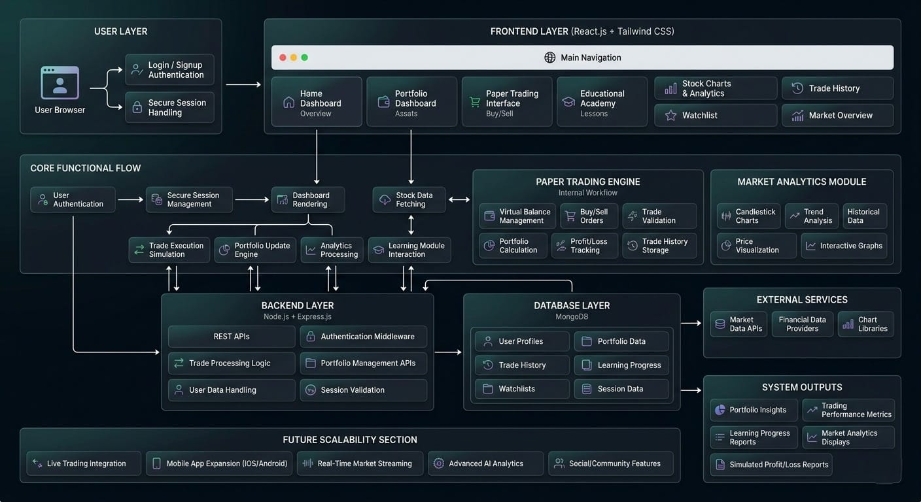
Fig 1: System Architecture of UpTrend
Future Enhancements
• Real-time market integration
• AI-based trading analytics
• Mobile application support
Language of the Work
• JavaScript
• React.js
• Node.js
• Express.js
• MongoDB
• HTML
• CSS
• Tailwind CSS
Whether the Work Has Been Published Already?
No
Inventor details

Sl No. | Name of Inventors | Nationality | Department/School | Email id & Contact No. | Signature
1 | Divya Joshi | India | Systems, SoCS | d.joshi2709@gmail.com  (7906989685) | 
2 | Aditya Narayan Gour | India | Systems, SoCS | adityagour925@gmail.com  (8006780067) | 
3 | Dr. Keshav Sinha | India | Systems, SoCS | Keshav.sinha@ddn.upes.ac.in (9570297390) | 

In case of Computer Software, please submit source code/ programing of the software in pdf format as well as executable format.
Note: Please email the duly filled and signed form to ipr@ddn.upes.ac.in

Copyright Application: V 1.5 2025

